Internal Linking

# Program 1:

<html>

<head>

    <title>work1</title>

</head>

<body>

    <a href="#S1">ANGULAR</a>&nbsp;&nbsp;

    <a href="#S2">PYTHON</a>&nbsp;&nbsp;

    <a href="#S3">REACT</a>&nbsp;&nbsp;

    <a href="#S4">PHP</a><br><br>

    <h1 id="S1">ANGULAR</h1>

    <img src="images/icons8-angular-48.png" height="200" width="200" alt="">

    <p>Angular 2.0 was announced at the ng-Europe conference 22-23 October 2014.[8][9] The drastic changes in the 2.0 version created considerable controversy among developers.[10] On April 30, 2015, the Angular developers announced that Angular 2 moved from Alpha to Developer Preview.[11] Angular 2 moved to Beta in December 2015,[12] and the first release candidate was published in May 2016.[13] The final version was released on 14 September 2016.

        On 13 December 2016 Angular 4 was announced, skipping 3 to avoid confusion due to the misalignment of the router package's version which was already distributed as v3.3.0.[14] The final version was released on 23 March 2017.Angular 2.0 was announced at the ng-Europe conference 22–23 October 2014.[8][9] The drastic changes in the 2.0 version created considerable controversy among developers.[10] On April 30, 2015, the Angular developers announced that Angular 2 moved from Alpha to Developer Preview.[11] Angular 2 moved to Beta in December 2015,[12] and the first release candidate was published in May 2016.[13] The final version was released on 14 September 2016.

        On 13 December 2016 Angular 4 was announced, skipping 3 to avoid confusion due to the misalignment of the router package's version which was already distributed as v3.3.0.[14] The final version was released on 23 March 2017.[15]

        Features in version 4.3:[citation needed]

        Introducing HttpClient, a smaller, easier-to-use, and more powerful library for making HTTP Requests.

        New router life cycle events for Guards and Resolvers. Four new events: GuardsCheckStart, GuardsCheckEnd, ResolveStart, ResolveEnd join the existing set of life cycle events such as NavigationStart.

        Conditionally disable animations.</p>

    <h1 id="S2">PYTHON</h1>

    <img src=" https://th.bing.com/th/id/OIP.aM88k3IR922UgNXrsVmi2AHaFj?w=480&h=360&rs=1&pid=ImgDetMain" alt="">

    <p>Python is a high-level, general-purpose programming language. Its design philosophy emphasizes code readability with the use of significant indentation.[32]

        Python is dynamically typed and garbage-collected. It supports multiple programming paradigms, including structured (particularly procedural), object-oriented and functional programming. It is often described as a "batteries included" language due to its comprehensive standard library.[33][34]

        Guido van Rossum began working on Python in the late 1980s as a successor to the ABC programming language and first released it in 1991 as Python 0.9.0.[35] Python 2.0 was released in 2000. Python 3.0, released in 2008, was a major revision not completely backward-compatible with earlier versions. Python 2.7.18, released in 2020, was the last release of Python 2.[36]

        Python consistently ranks as one of the most popular programming languages, and has gained widespread use in the machine learning community.Python was invented in the late 1980s[41] by Guido van Rossum at Centrum Wiskunde & Informatica (CWI) in the Netherlands as a successor to the ABC programming language, which was inspired by SETL,[42] capable of exception handling and interfacing with the Amoeba operating system.[11] Its implementation began in December 1989.[43] Van Rossum shouldered sole responsibility for the project, as the lead developer, until 12 July 2018, when he announced his "permanent vacation" from his responsibilities as Python's "benevolent dictator for life" (BDFL), a title the Python community bestowed upon him to reflect his long-term commitment as the project's chief decision-maker[44] (he's since come out of retirement and is self-titled "BDFL-emeritus"). In January 2019, active Python core developers elected a five-member Steering Council to lead the project.[45][46]

        Python 2.0 was released on 16 October 2000, with many major new features such as list comprehensions, cycle-detecting garbage collection, reference counting, and Unicode support.[47] Python 3.0, released on 3 December 2008, with many of its major features backported to Python 2.6.x[48] and 2.7.x. Releases of Python 3 include the 2to3 utility, which automates the translation of Python 2 code to Python 3.</p>

    <h1 id="S3">REACT</h1>

    <img src="https://encrypted-tbn0.gstatic.com/images?q=tbn:ANd9GcT7Isxe4pqMxfjPccOdKRM3-zdiQ8oZc07Ypw&s" alt="">

    <p>React (also known as React.js or ReactJS) is a free and open-source front-end JavaScript library[4][5] for building user interfaces based on components. It is maintained by Meta (formerly Facebook) and a community of individual developers and companies.[6][7][8]

        React can be used to develop single-page, mobile, or server-rendered applications with frameworks like Next.js. Because React is only concerned with the user interface and rendering components to the DOM, React applications often rely on libraries for routing and other client-side functionality.[9][10] A key advantage of React is that it only rerenders those parts of the page that have changed, avoiding unnecessary rerendering of unchanged DOM elements.Declarative

        React adheres to the declarative programming paradigm.[11]: 76  Developers design views for each state of an application, and React updates and renders components when data changes. This is in contrast with imperative programming.[12]

        Components

        React code is made of entities called components.[11]: 10–12  These components are modular and reusable.[11]: 70  React applications typically consist of many layers of components. The components are rendered to a root element in the DOM using the React DOM library. When rendering a component, values are passed between components through props (short for "properties"). Values internal to a component are called its state.[13]

        The two primary ways of declaring components in React are through function components and class components.[11]: 118 [14]: 10

        Function components

        Function components are declared with a function (using JavaScript function syntax or an arrow function expression) that accepts a single "props" argument and returns JSX. From React v16.8 onwards, function components can use state with the useState Hook.</p>

    <h1 id="S4">PHP</h1>

    <img src="images/icons8-php-64.png" height="200" width="200" alt="">

    <p>PHP is a general-purpose scripting language geared towards web development.[8] It was originally created by Danish-Canadian programmer Rasmus Lerdorf in 1993 and released in 1995.[9][10] The PHP reference implementation is now produced by the PHP Group.[11] PHP was originally an abbreviation of Personal Home Page,[12][13] but it now stands for the recursive initialism PHP: Hypertext Preprocessor.[14]

        PHP code is usually processed on a web server by a PHP interpreter implemented as a module, a daemon or a Common Gateway Interface (CGI) executable. On a web server, the result of the interpreted and executed PHP code—which may be any type of data, such as generated HTML or binary image data—would form the whole or part of an HTTP response. Various web template systems, web content management systems, and web frameworks exist that can be employed to orchestrate or facilitate the generation of that response. Additionally, PHP can be used for many programming tasks outside the web context, such as standalone graphical applications[15] and drone control.[16] PHP code can also be directly executed from the command line.

        The standard PHP interpreter, powered by the Zend Engine, is free software released under the PHP License. PHP has been widely ported and can be deployed on most web servers on a variety of operating systems and platforms.[17]

        The PHP language has evolved without a written formal specification or standard, with the original implementation acting as the de facto standard that other implementations aimed to follow.

        W3Techs reports that as of 23 March 2024 (the four months after the PHP 8.3 release), PHP is used by 76.4% of all websites whose programming language could be determined, and 57.2% thereof use PHP 7 which is outdated and known to be insecure.[18] Additionally, PHP 8.0 is no longer supported, meaning the vast majority of PHP users utilize outdated versions, and well over half of all websites, PHP-using or not (whose programming language could be determined) are insecure.</p>

</body>

</html>

# Output:

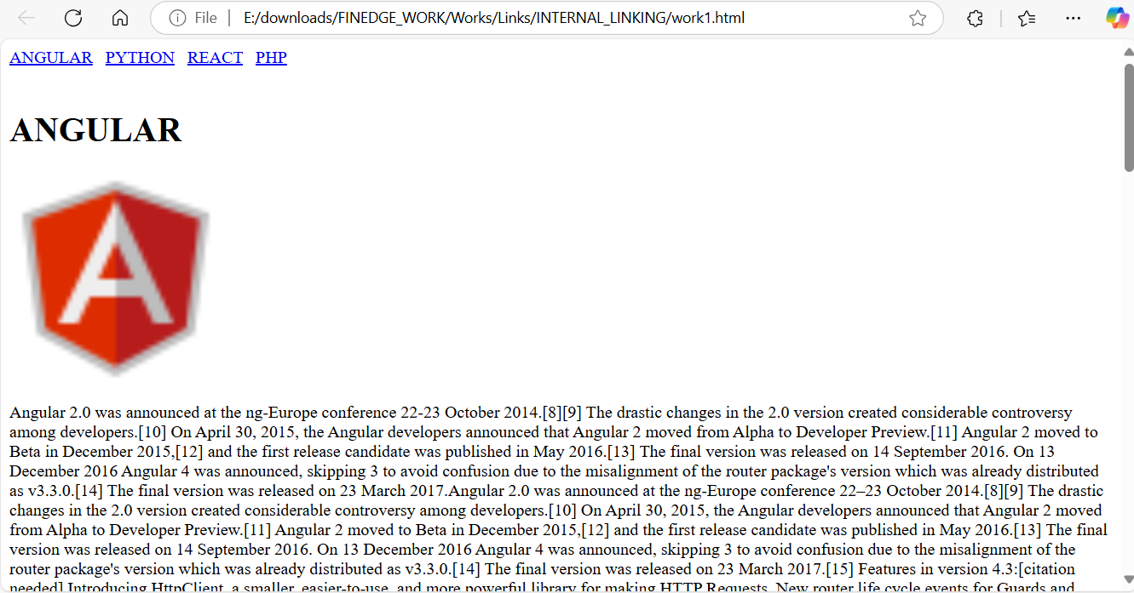

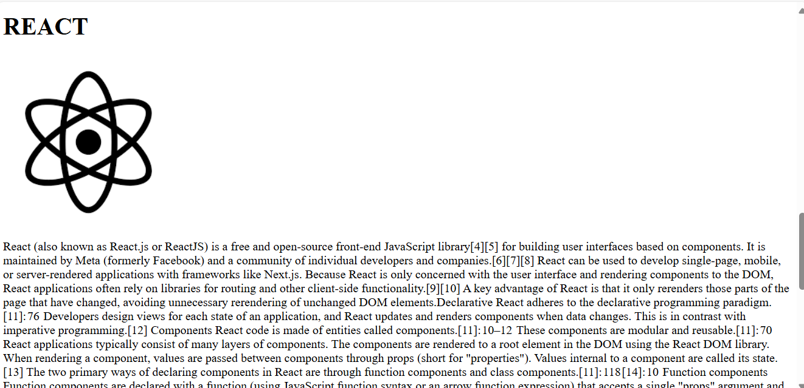

# Program 2 :

<html>

<head>

    <title>work2</title>

</head>

<body>

    <table height="50" width="350">

        <tr>

            <td><a href="#a1">HOME</a></td>

            <td><a href="#a2">ABOUT</a></td>

            <td><a href="#a3">SERVICE</a></td>

            <td><a href="#a4">GALLERY</a></td>

        </tr>

    </table>

    <br><br>

    <table height="600" width="1350">

        <tr id="a1">

            <td><center><font color="blue"><h1>CAFE CAZAMIA</h1></font></center></td>

        </tr>

        <tr>

            <td><img src="images/cafe4.jpeg" alt="" height="550" width="1350"></td>

        </tr>

     </table>

     <br><br>

     <table height="600" width="1350">

        <tr id="a2"><td colspan="3"><font color="green"><h2>ABOUT US</h2></font></td></tr>

        <tr>

            <td><img src="images/cafe1.jpeg" alt="" height="550" width="550"></td>

            <td width="500">

                <font color="red">

                    <b>

                    CAFE CAZAMIA <br>

                    cafecazamia@gmail.com <br>

                    Landmark11,second street,bengaluru -India<br>

                    987654320

                    </b>

                </font>

                <hr>

                <p>

                    A company description is an overview or summary of a business. It's an important part of a business plan that often briefly describes an organization's history, location, mission statement, management personnel and, when appropriate, legal structure.

                    A company description is an overview or summary of a business. It's an important part of a business plan that often briefly describes an organization's history, location, mission statement, management personnel and, when appropriate, legal structure.

                    A company description is an overview or summary of a business. It's an important part of a business plan that often briefly describes an organization's history, location, mission statement, management personnel and, when appropriate, legal structure.

                    A company description is an overview or summary of a business. It's an important part of a business plan that often briefly describes an organization's history, location, mission statement, management personnel and, when appropriate, legal structure.

                    A company description is an overview or summary of a business. It's an important part of a business plan that often briefly describes an organization's history, location, mission statement, management personnel and, when appropriate, legal structure.

                    A company description is an overview or summary of a business. It's an important part of a business plan that often briefly describes an organization's history, location, mission statement, management personnel and, when appropriate, legal structure.

                    A company description is an overview or summary of a business. It's an important part of a business plan that often briefly describes an organization's history, location, mission statement, management personnel and, when appropriate, legal structure.

                </p>

            </td>

            <td><img src="images/flower.png" alt=""></td>

        </tr>

     </table>

     <br><br>

     <table height="600" width="1350">

        <tr id="a3"><td  colspan="2"><font color="green"><h2>SERVICE</h2></font></td></tr>

        <tr bgcolor="grey">

            <td>

                <h3>

                    <ol type="1">

                        <li>home delivery</li>

                        <li>parcel</li>

                        <li>table space</li>

                        <li>party hall</li>

                        <li>capuccino</li>

                        <li>pasteries</li>

                        <li>desserts</li>

                        <li>premium cakes</li>

                        <li>coffees</li>

                    </ol>

                </h3>

            </td>

            <td>

                <img src="https://t4.ftcdn.net/jpg/03/03/49/75/360_F_303497515_ZHOwfTtuo5sYpAeoqWRZnkXZNZDKZeMz.jpg" alt="" height="550" width="550">

            </td>

        </tr>

     </table>

     <br><br>

     <table height="600" width="1350">

        <tr id="a4"><td colspan="3"><font color="green"><h2>GALLERY</h2></font></td></tr>

        <tr>

            <td><img src="images/cafe2.jpeg" alt="" height="350" width="350"></td>

            <td><img src="images/cafe3.jpeg" alt="" height="350" width="350"></td>

            <td><img src="images/cafe8.jpeg" alt="" height="350" width="350"></td>

        </tr>

        <tr>

            <td><img src="images/cafe5.jpeg" alt="" height="350" width="350"></td>

            <td><img src="images/cafe6.jpeg" alt="" height="350" width="350"></td>

            <td><img src="images/cafe7.jpeg" alt="" height="350" width="350"></td>

        </tr>

    </table>

</body>

</html>

# OutPut :

